**1. INTRODUCTION**

* 1. **Project Overview**

The agricultural and food processing industries face significant challenges in ensuring the quality of fruits and vegetables reaching end consumers. One of the primary concerns is post-harvest losses, often caused by inefficient sorting and quality inspection processes. Traditional sorting techniques, which heavily rely on manual inspection, are not only time-consuming but also prone to human errors. These limitations often result in spoiled produce reaching retail shelves, leading to increased food wastage, dissatisfied customers, and financial losses for producers and retailers.

To address these challenges, the NutriGaze Smart Sorting system has been developed as a reliable, automated, and scalable solution. NutriGaze leverages state-of-the-art computer vision and deep learning techniques to classify fruits and vegetables based on their freshness and quality. By integrating transfer learning with the well-established VGG16 model, NutriGaze is capable of accurately distinguishing between healthy and rotten produce by analysing images captured during the sorting process.

The solution has been designed with ease of deployment and scalability in mind, making it suitable for various environments such as food processing plants, distribution centers, and retail supermarkets. Through NutriGaze, businesses can significantly reduce post-harvest losses, ensure only high-quality produce reaches consumers, and enhance operational efficiency.

**1.2 Purpose of the Project**

The primary purpose of the NutriGaze project is to revolutionize the quality inspection process for fruits and vegetables using artificial intelligence and image-based classification. By automating the detection of rotten or spoiled produce, the system helps overcome the limitations of traditional manual sorting, thereby ensuring better food quality and reducing wastage across the supply chain.

**Key Objectives of the Project:**

* To develop an AI-powered image classification system capable of differentiating healthy produce from spoiled or rotten items.
* To minimize food wastage by detecting and removing low-quality produce at an early stage.
* To enhance operational efficiency in food processing plants, warehouses, and retail chains by providing an automated quality control mechanism.
* To build a scalable and easy-to-use solution that can be adopted by stakeholders at various levels of the agricultural and food supply chain.
* To increase consumer confidence and satisfaction by ensuring only high-quality, fresh produce reaches the market.

The NutriGaze project is not just a technological advancement but a step towards building a more sustainable, efficient, and trustworthy food supply chain.

**2. IDEATION PHASE**

2.1 Problem Statement

2.2 Empathy Map Canvas

2.3 Brainstorming

**3. REQUIREMENT ANALYSIS**

3.1 Customer Journey map

3.2 Solution Requirement

3.3 Data Flow Diagram

3.4 Technology Stack

**4. PROJECT DESIGN**

4.1 Problem Solution Fit

4.2 Proposed Solution

4.3 Solution Architecture

**5. PROJECT PLANNING & SCHEDULING**

5.1 Project Planning

**6. FUNCTIONAL AND PERFORMANCE TESTING**

6.1 Performance Testing

**7. RESULTS**

**7.1 Output Screenshots**

The complete execution of the Smart Sorting application is shown in the images step by step as shown below.

**Step 1:** Run the app.py code and you will get a link in terminal as <https://127.0.0.1.5050> to access web page and to do the other process.

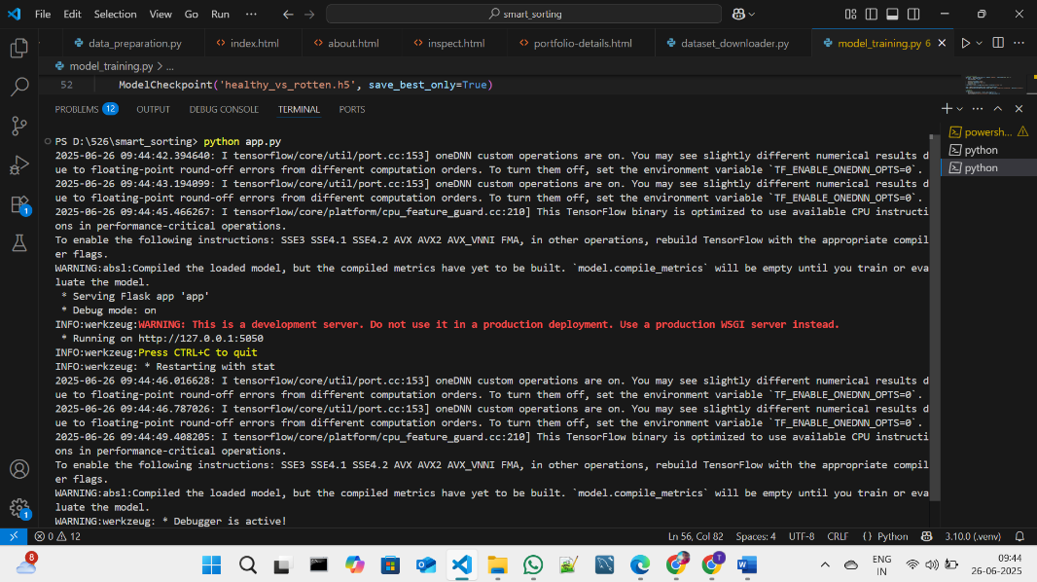

**Fig 7.1.1: Code running in Terminal**

**Step 2:** Click on that link a web page of Nutrigaze will be open in the web browser.

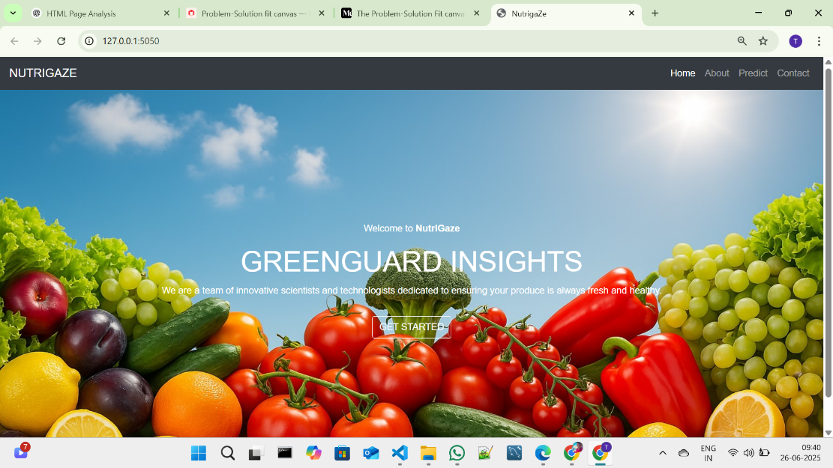

**Fig 7.1.2: NUTRIGAZE Home Page**

**Step 3:** Click on GET STARTED or PREDICT option to open the prediction page.

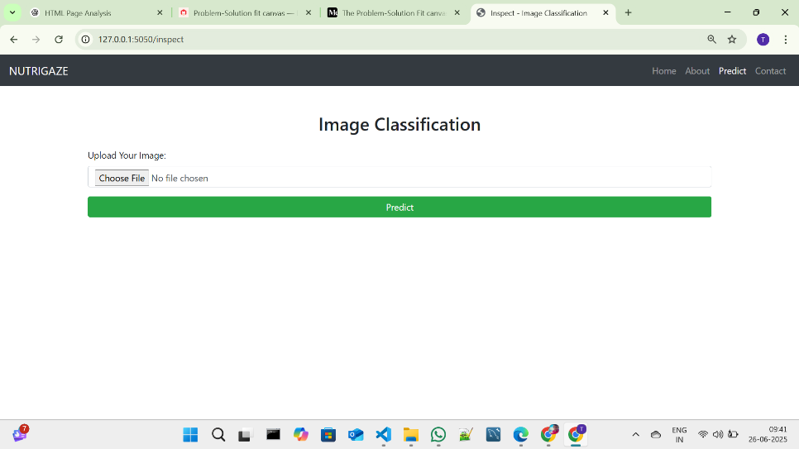

**Fig 7.1.3: Prediction page in NUTRIGAGE**

**Step 4:** Click on choose file option to choose the images that need to predict.

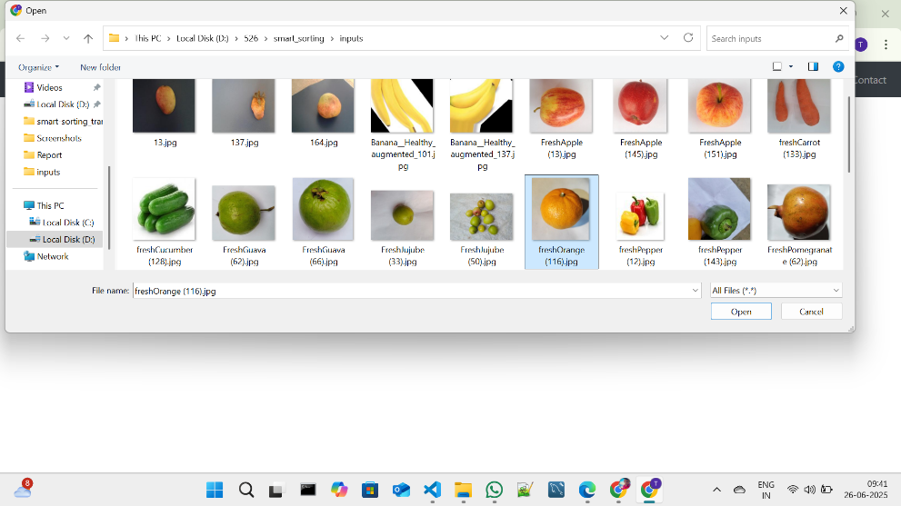

**Fig 7.1.4: Window to choose image for prediction**

Select any image for prediction and click on Open.

**Step 5:** Click on Predict to predict the quality of selected image.

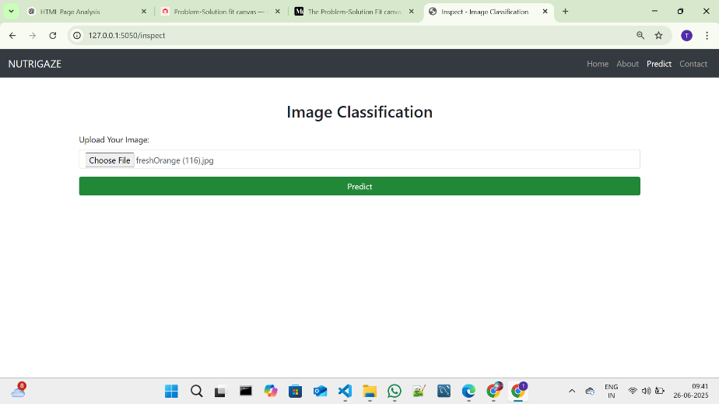

**Fig 7.1.5: Image selected in prediction page**

**Step 6:** After clicked on the predict button the model predicts the image quality and displays the quality of image.

The below images are the some of samples tested for prediction.

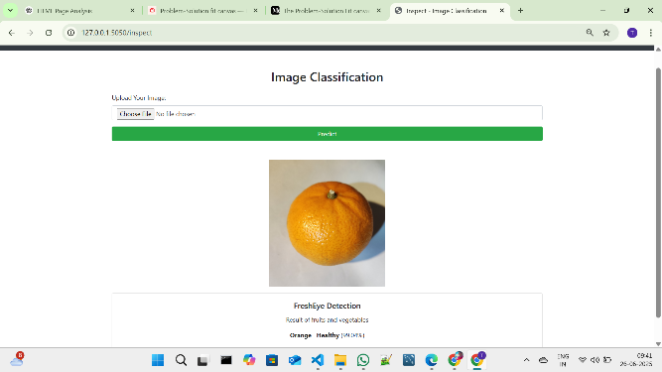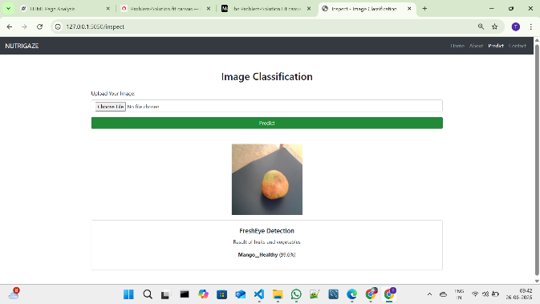

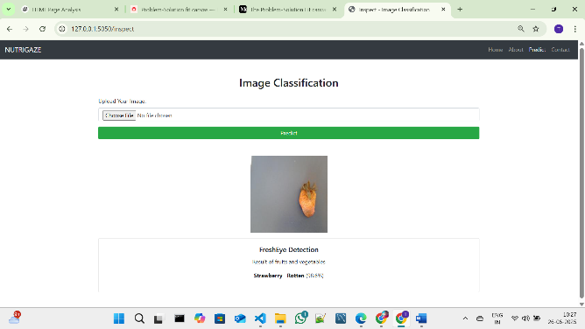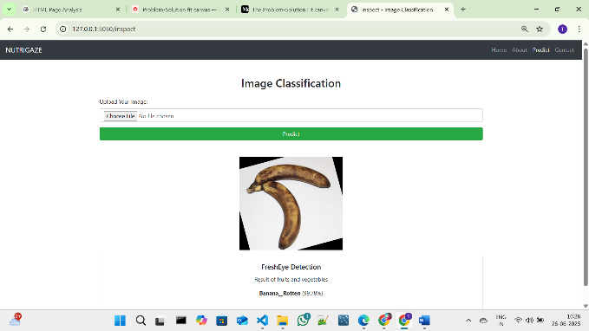

**Fig 7.1.6: Prediction output for the several inputs with accuracy**

After the Images Predicted the images will be stored in the uploads folder as fresh and rotten as shown in the figure given below.

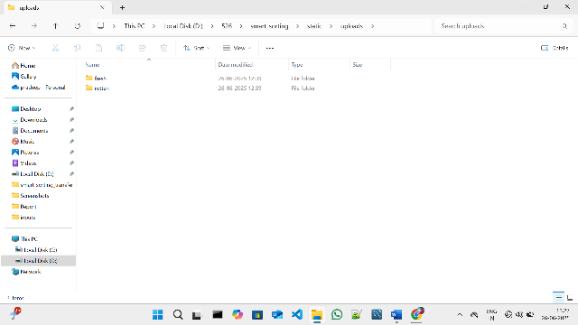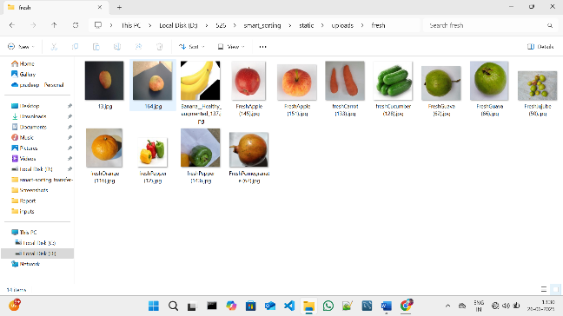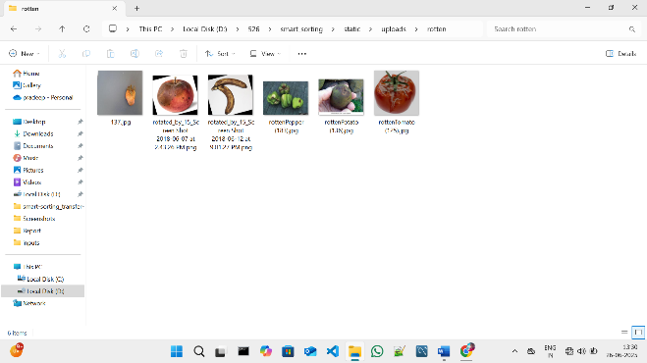

**Fig 7.1.7: Folder Structure to store predicted images**

**8. ADVANTAGES & DISADVANTAGES**

**8.1 Advantages of NutriGaze Smart Sorting System**

| **Advantage** | **Description** |
| --- | --- |
| **Accurate Detection** | Deep learning ensures high accuracy in classifying fresh vs. rotten produce. |
| **Automation & Efficiency** | Reduces manual labor and speeds up the sorting process significantly. |
| **Reduces Post-Harvest Losses** | Early detection of spoiled produce helps minimize food wastage. |
| **Consumer Trust & Satisfaction** | Ensures only quality fruits and vegetables reach consumers, improving confidence. |
| **Scalability** | Can be integrated into various food processing environments with minimal effort. |
| **Data-Driven Decisions** | Provides objective, consistent results reducing human error. |
| **Cost Savings** | Reduces losses due to rejected or returned spoiled produce, improving profitability. |

**Table 8.1: Advantages**

**8.2 Disadvantages / Limitations**

| **Disadvantage** | **Description** |
| --- | --- |
| **Dependence on Image Quality** | Poor image quality or improper lighting can reduce prediction accuracy. |
| **Initial Setup Cost** | Requires investment in model development, hardware, and infrastructure. |
| **Limited to Trained Categories** | The model only works for fruits and vegetables it has been trained on. |
| **External Factors** | Complex external factors like hidden defects or odor cannot be detected. |
| **Requires Technical Expertise** | Maintaining, updating, and troubleshooting the AI system requires skilled personnel. |

**Table 8.2: Disadvantages**

**9. CONCLUSION**

The NutriGaze Smart Sorting System effectively addresses the critical issue of post-harvest losses due to spoiled fruits and vegetables. By leveraging deep learning techniques and transfer learning using VGG16, the project offers an automated, reliable, and scalable solution for classifying fresh and rotten produce. This not only enhances food quality and safety but also contributes to reducing wastage and boosting consumer confidence. Though there are challenges such as dependence on image quality and system limitations to trained categories, the system shows promising results and practical applicability in real-world scenarios like food processing units and supermarkets.

**10. FUTURE SCOPE**

The Smart Sorting system can be further enhanced and expanded in several ways:

* **Support for More Categories:** Extend the model to include more fruits, vegetables, and other perishable food items.
* **Real-time Integration:** Integration with conveyor belt sorting systems for real-time industrial applications.
* **Mobile App Development:** Building a mobile version of the system for on-the-go quality checks by farmers and retailers.
* **Multi-Modal Detection:** Combining image-based detection with sensors (e.g., smell, temperature) for more comprehensive freshness checks.
* **Model Improvements:** Further fine-tuning the model with more diverse datasets to improve generalization for external images.
* **Edge Deployment:** Optimizing the model for deployment on edge devices to enable offline and on-field usage.

**11. APPENDIX**

**Source Code:**

All codes are submitted in Git-Hub Repository.

**Git-Hub Repository Link:**

<https://github.com/palleboinaanjali/Smart_Sort>

**Dataset Link:**

<https://www.kaggle.com/datasets/muhammad0subhan/fruit-and-vegetable-disease-healthy-vs-rotten>

or   
Use the dataset_downloader code in Git-Hub Repository

**Project Demo Link:**

<https://drive.google.com/file/d/1A6EoWlVuJSrBZ5-Gu3sMr9HQ62Ivewli/view?usp=drivesdk>